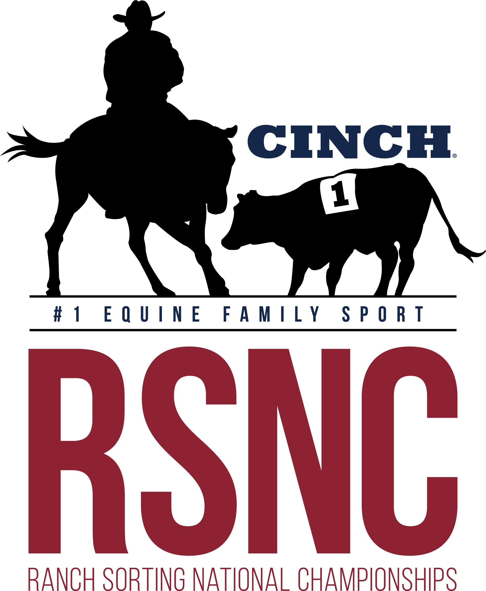

BSC ARENA
Waynesboro Ga.

Ranch Sorting
National Championships

1 SHOW 2 DAYS !!!
Friday August 11th
Covered
Arena
Saturday August 12th
All New Contestants
Receive a free RSNC Membership!

Concessions
Available

Friday August 11th
*Books open @ 4:30pm - Sort @ 5:30pm*
Masters #10 HC - $29 EF
#5 HC - $29 EF
#10 HC - $29 EF

Saturday August 12th
*Books open @ 8am - Sort @ 9am*
Youth All Draw - $27 EF (12 years old and below)
All Levels HC - $47 EF (#2 floor) - 60%Payback (capped at highest entry combo)
Beginner RH #10 HC (#1 cap on sorter) - $27 EF
All Levels WH HC/#6 Inc - $29 EF (capped at highest entry combo)
Rookie #11 HC (#2 cap on sorter) - $29 EF
#8 HC - $29 EF
All Classes 50% payback except All Levels 60% payback
*Entry Fees include a $3/entry RSNC sanctioning fee and $4/entry cattle fee ~ 5 Ride Limit ~
Mandatory Draw- Pick 1 Automatically Draw 1 (Pick up to 4 or Draw All 5)

Location:  BSC Covered Arena  3976 Hwy 24 South  Waynesboro, Ga | Call to Reserve Stalls and RV  706-551-2190  **All info on flyer subject to change**
Contact Johnny Lovett at #706-551-2190 or Cliff Chancey at #706-840-3971 with any questions

